TIDES

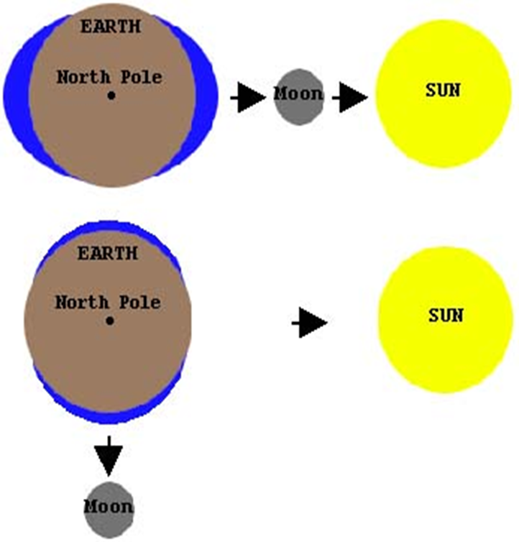
1. Why is the Moon’s gravitational pull on the Earth’s water twice as strong as the sun?

2. What causes tides?

3. Explain how gravity affects the Earth and the Moon.

4. What effect does the gravitational attraction of the moon have on the Earth’s oceans?

5. Why do we have two tides each day?

6. High tide occurs when the gravitational pull of the Moon causes

7. Why is there a stronger gravitational pull during a full or new moon?

8. What does the ‘spring’ in spring tide mean?

9. Why do we have smaller tides during the first and third quarters of the Moon’s phases?

10. During a _________________ tide both the moon and the sun pull on the ocean water. The high tide is more extreme.
During a _________________ tide, the sun and the moon pull the opposite of each other. High tide is less extreme.

11. True or False
It takes the moon one month to orbit the earth. __________
The moon rotates in the opposite direction to the earth. __________
The moon rotates at a much slower speed than Earth. __________

12. The tidal cycle is not 24 hours long, but 24 hours and 50 minutes long because it takes an extra 50 minutes each day for the moon to be in the same location, relative to a point on earth, to the previous day. This is why
__________________________________________________________________________________________________
__________________________________________________________________________________________________
__________________________________________________________________________________________________

